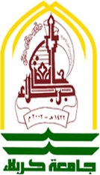
Republic of Iraq
Ministry of Higher Education
And Scientific Research
University of Karbala
College Education of pure Sciences
Department of Mathematics

Compact set

A research Submitted to
The Council of the College Education of Pure Sciences
University of Karbala
In Partial Fulfillment of the Requirements for the degree of Bachelor of
Science in Mathematics

By
Ali Abd Alwahd Fadel
Meriam Abd Ala'ameer
Noor Hassan Fadel

Supervised by
Lecher Ghassan A. Khtan

1437 A.H. 2016 A.D.

